Home

2)feels empty on right side
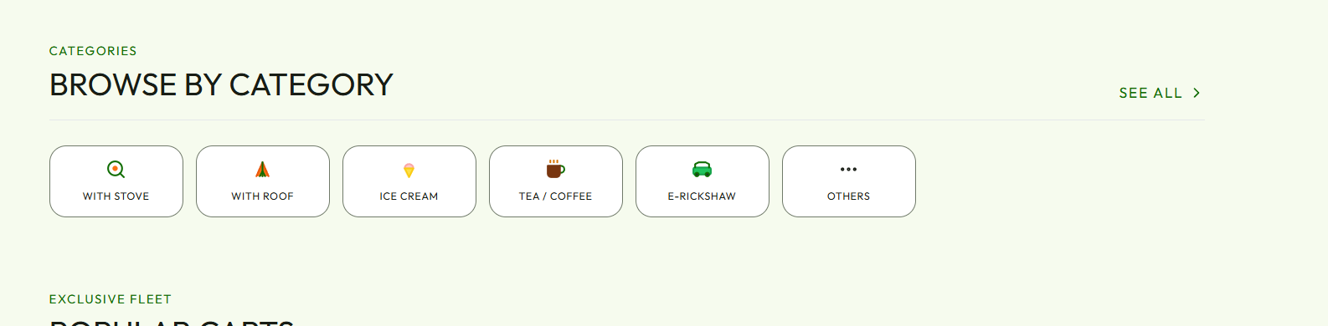

4) fill browser is in english even when the language is changed into tamil,need improvement
Manage the space on the side. The search by in two lines makes the in single line. The text in the image is not visible properly check that
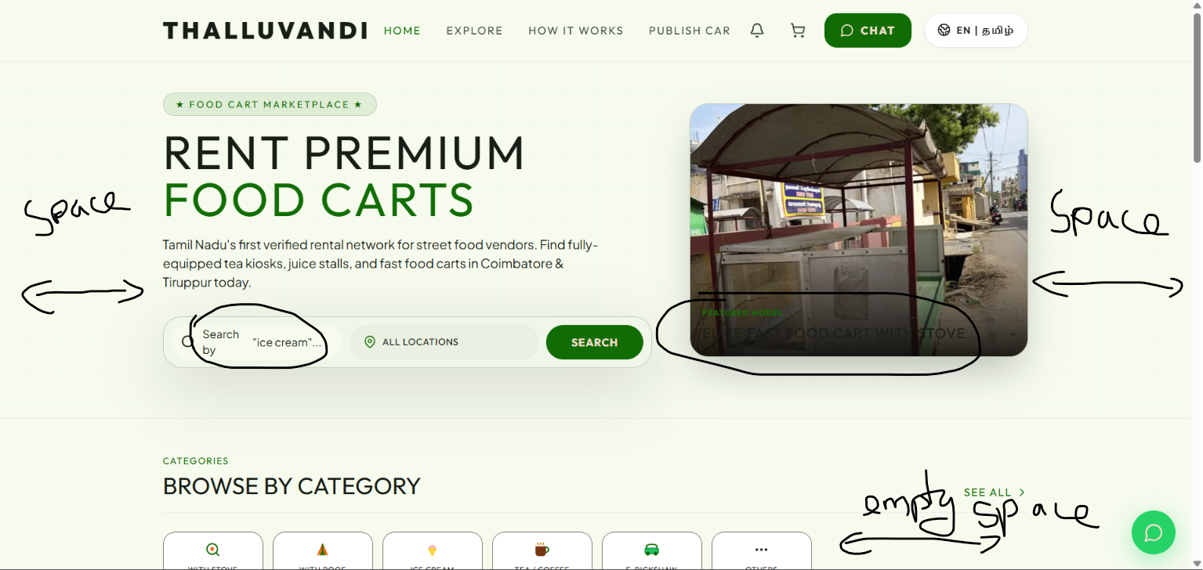
Remove all the dummy values about carts and create a table in database for sales carts
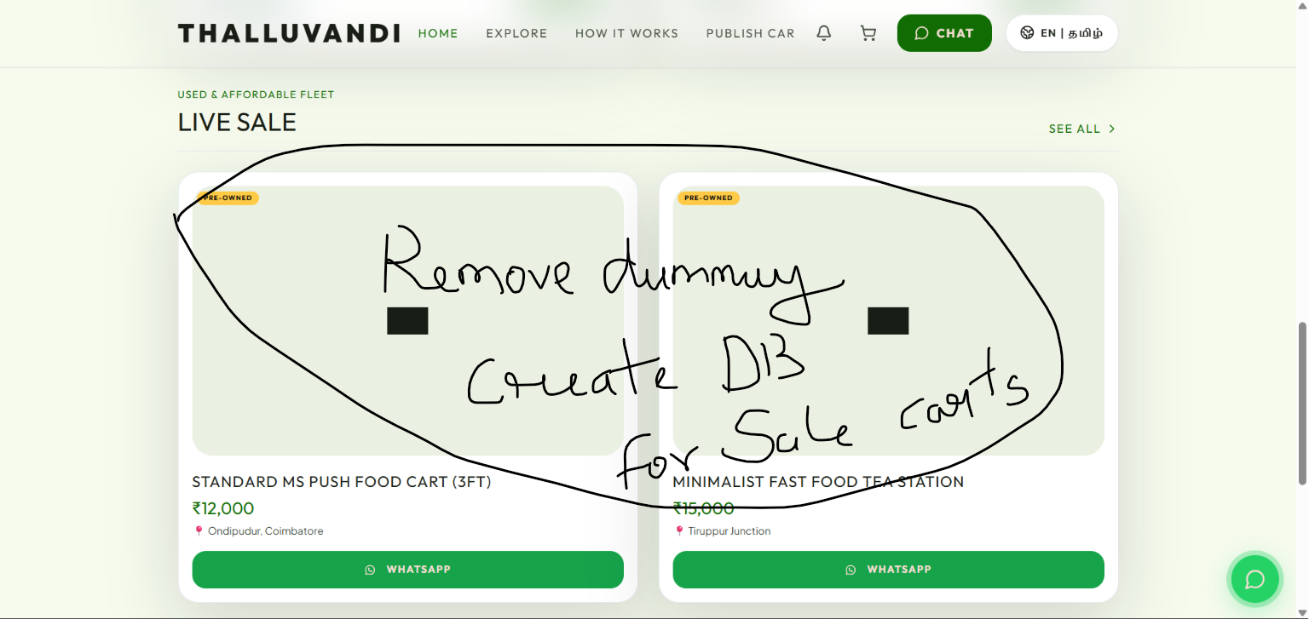

Explore

2) fill browser is in english even when the language is changed into tamil,need improvement

3)this tab is need to be come above for filtering/sorting and user efficiency

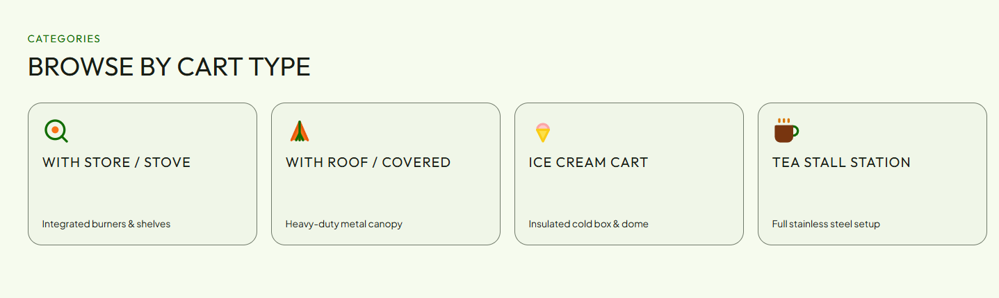

6)icons need improvement

8) Miss alignment of the text,
Bottom button (book now) and (back) size are large make it proper in desktop
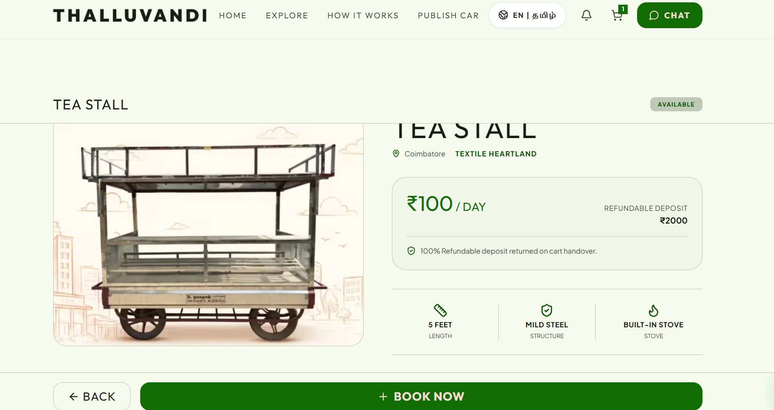

11) All carts have default features. That should based on the carts

Add some details about the cart in the empty space of the cart card

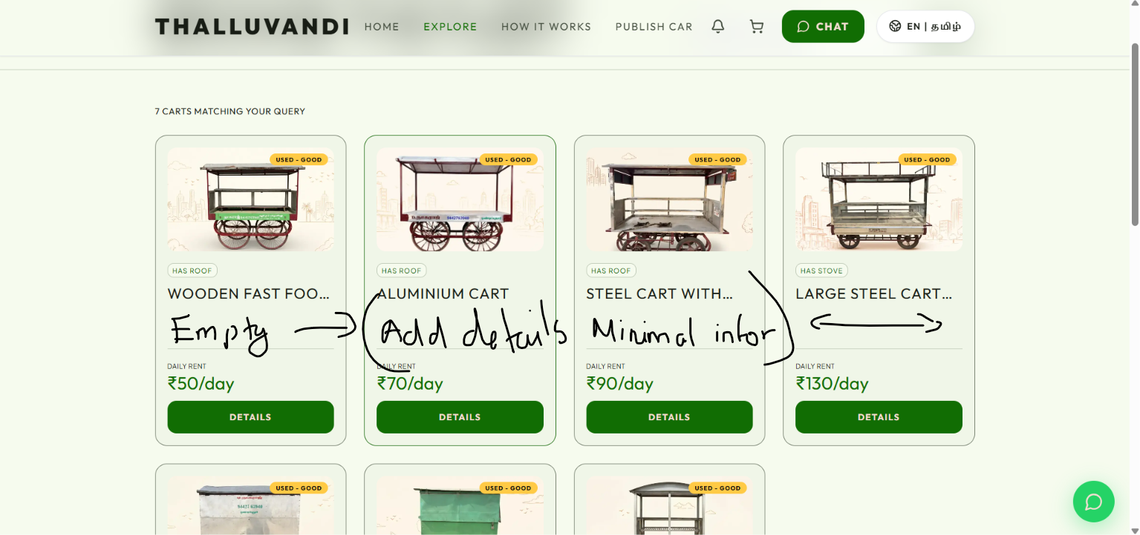this option should be in the top of the page like in the home page. 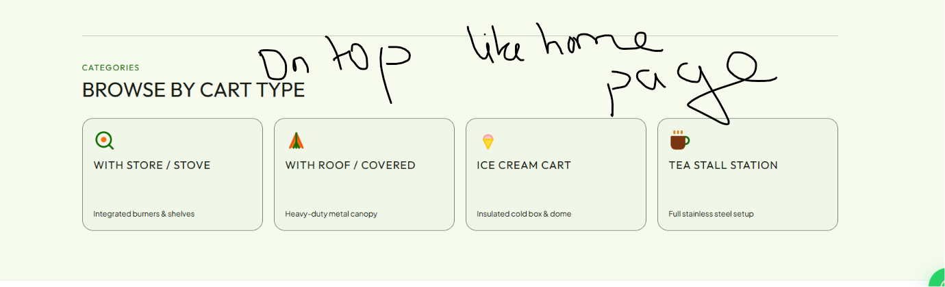
empty space in the top and the text is hidden below that. And this cart has no stove but the feature is showing that this cart has a stove. Empty space in the cart price cart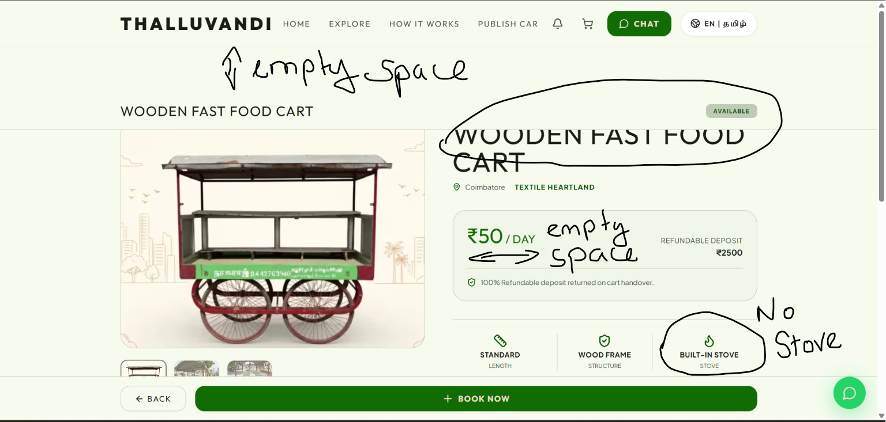
The empty space should be filled. And the whatsapp inquiry should be redirect to the form of contact not redirected to the whatsapp directly without filling details 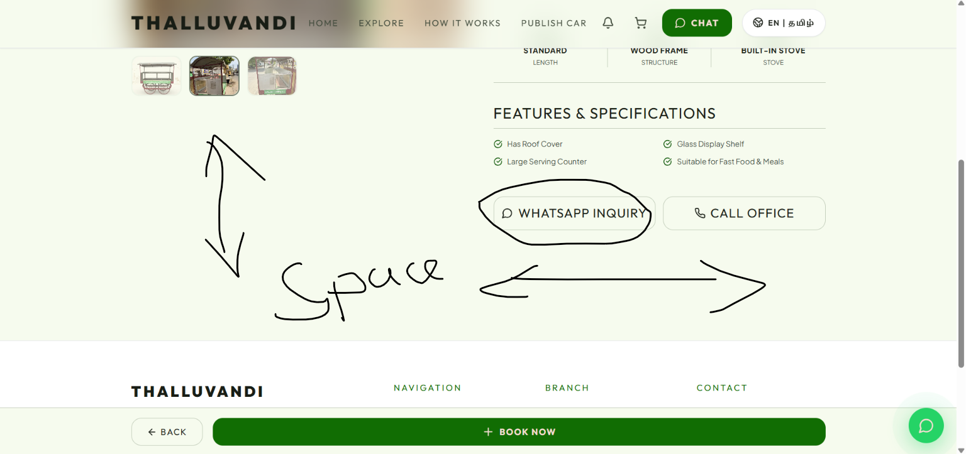remove the gps coordinates in the whole website. Add the location name. People does not know the gps coordinates so change that into the location name 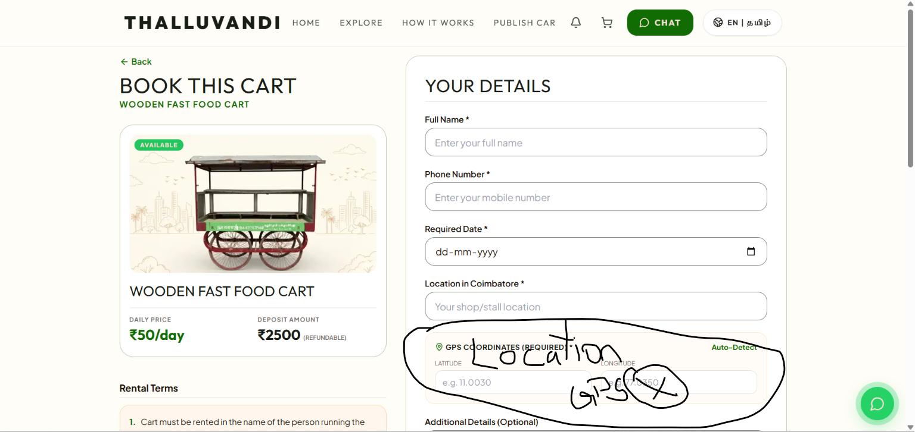the mobile view is not nice empty spaces are there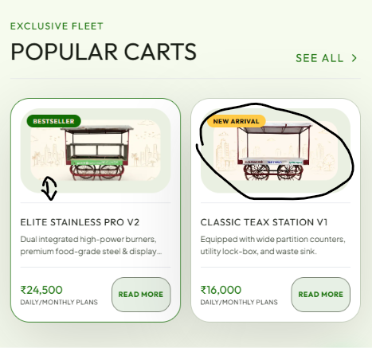

how its works

3) Remove the how it works totally

Profile
The profiles of the user should be local storage and updates the notification through local storage if possible

The profile for the cart vendor should be created in the database. With some informations and their cart details (images, price, details)

The profile option in the mobile version is only displayed to the cart vendor. Not the user

Others

1)language change button should be moved to a another place to make it user friendly for notification and cart button

It feels like two button(notification and cart) are are ghosted between language and chat button

2) Remove the rental cart option - when you click the book now it should be redirected to the form in the website.
3) remove all the dummy , local , data (carts,price)

4) Both mobile and desktop should be optimized.
The structure of both should be perfect and useable

5) Changing to Tamil should change all the text to Tamil . Now few texts are only changing to Tamil.

6) Location detection is working but that location detected should be shown to the user. And they are able to change the location.
The location options should be in filter and search option in home page

Both mobile and desktop versions should have the same pages.
HOME - EXPLORE -LIST - CONTACT For user | plan this according to the needs
HOME - LIST - CONTACT - PROFILE for cart vendor | check the user role and show the pages.

EXPLORE should be highlighted for user (analyse this and change it)
LIST should be highlighted for vendor

LIST / PUBLISH should be required to create a profile. Before filling in the details. The details entered while creating a profile should be pre filled in the form for listing.

Make the listing process in a few steps.
CREATE PROFILE -> BASIC DETAILS (Locations , no.of carts,etc) -> LIST FOR EACH CART (Name,specs, price, etc) -> send approval request to admin

The data is not proper in the admin page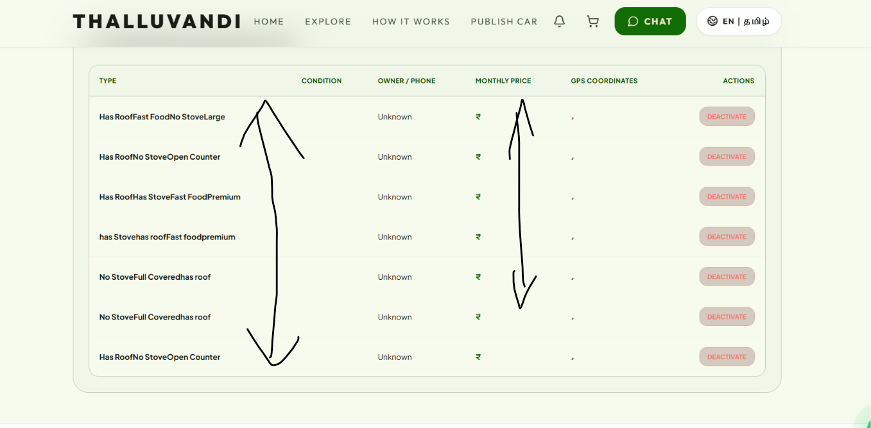

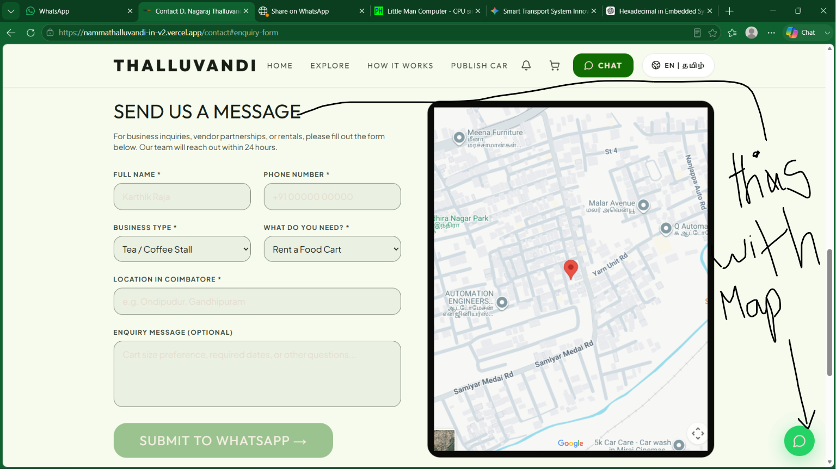

Map with send us message option

Remove the cart option

